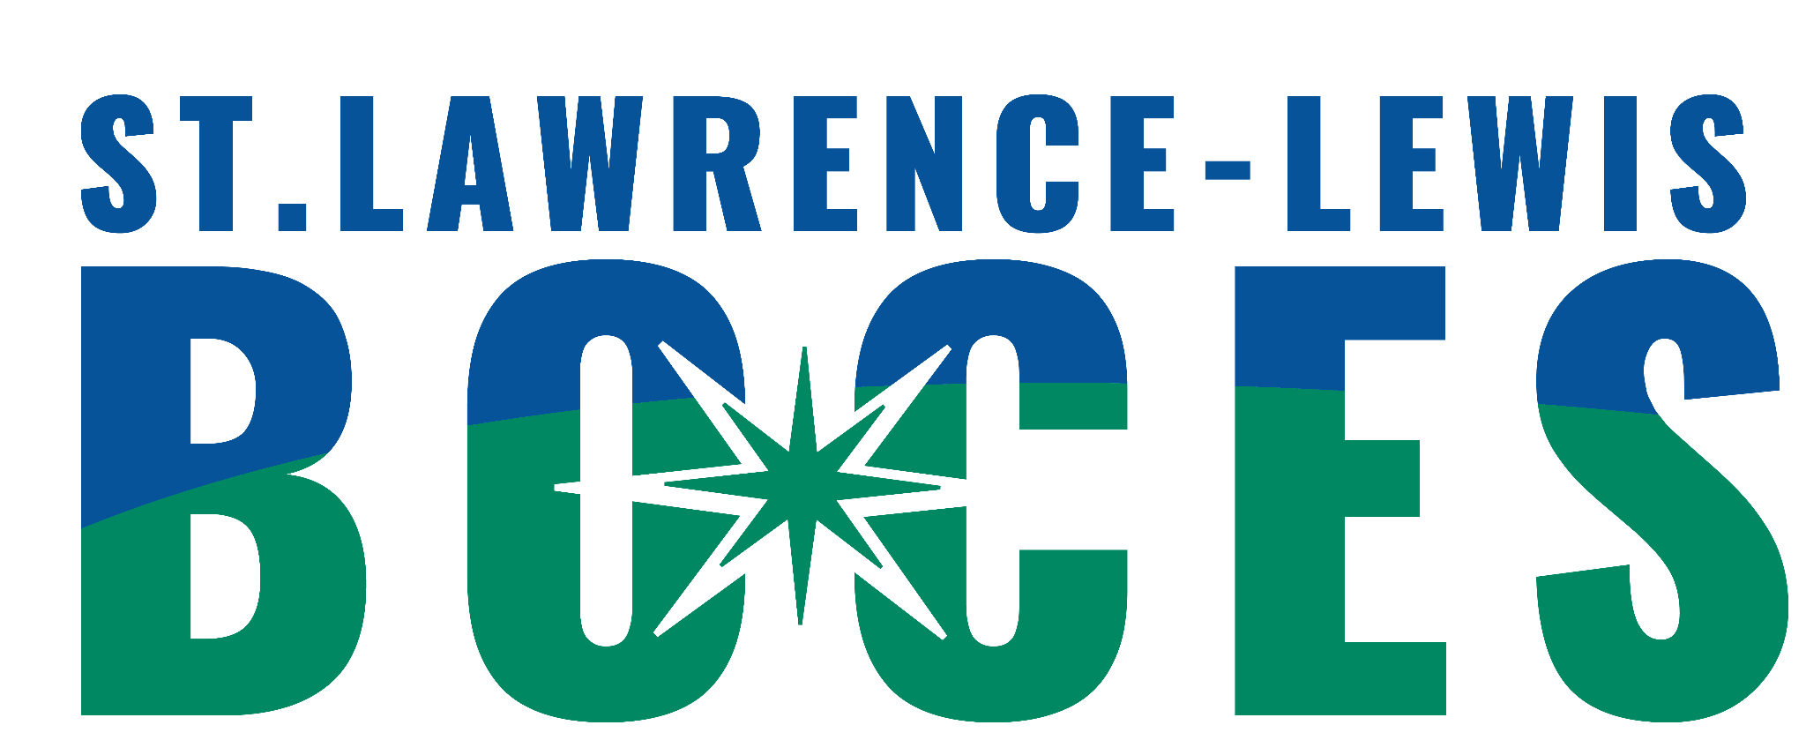
St. Lawrence-Lewis BOCES
12:1:1 Programs
Ogdensburg and Potsdam

Date of Referral: __________________________________

Student’sName:________________________________DOB:__________Age:__________

Parent/Guardian(s):__________________________________________________________

Address:___________________________________________________________________

Phone/Contact Number:_______________________________

Home District:____________________________Classification:________________________

Other Agencies involved with student (If known, please include name of contact person):

Mental Health Service Provider:___________________________________________

Outside Service Provider:_______________________________________

Dept. of Social Services:_________________________________________________

Other:________________________________________________________________

EDUCATIONAL PROFILE

Most recent class placement (include names of teacher and counselor):

Please list skills or goals you would like the student to get out of life skills 12:1:1.

What related services are they currently receiving?

Does this student have a Functional Behavioral Assessment (FBA) and Behavior Intervention Plan (BIP) in place? If so, date of last FBA _________________ Or an individual crisis support plan (ICSP) in place?

What is your tentative, future educational placement for this student?

Please attach the following paperwork to this form and send to:
1. Current IEP
2. Psychological Evaluation
3. List of current medications (at home and at school)
4. FBA and BIP/ Discipline Referrals (If applicable)
5. Related Service Evaluations
6. Progress Reports
7. Contacts with External Agencies

If sending by email, which is preferred, please send copies to the following:
reginald.mcdonald@sllboces.org
kady.sharp@sllboces.org for Potsdam Central School
julie.austinkormanyos@sllboces.org Kennedy School Ogdensburg

If sending by mail, send completed referral to:
St. Lawrence-Lewis BOCES
P.O. Box 231
Canton, NY 13617
Attn: Crystal LaPoint

The 12:1:1 team will review the referral to determine placement based on information provided and similarity of need once all information necessary is received according to the BOCES Intake Guidelines.

