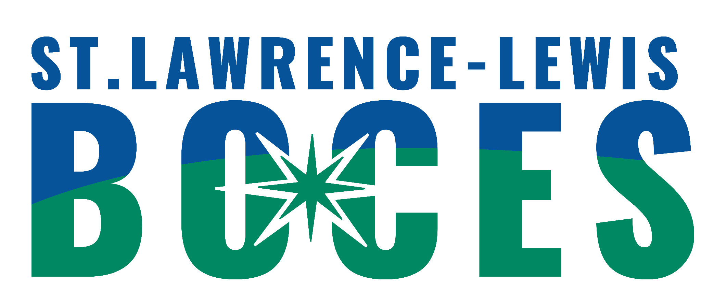
St. Lawrence-Lewis BOCES
6:1:1 Programs
ABA Programs - Canton & Potsdam Referral Form

Date of Referral: __________________________________

Student’sName:________________________________DOB:__________Age:__________

Parent/Guardian(s):__________________________________________________________

Address:___________________________________________________________________

Phone/Contact Number:_______________________________

Home District:____________________________Classification:________________________

What is the student’s current programming?

___SEIT

___SCIS

___Special Class (ratio: ____)

Related Services:
___Speech

___OT

___PT

EDUCATIONAL PROFILE

Most recent class placement (include names of teacher(s)):

How does this child communicate their wants and needs?

Please list any challenging behaviors that you have concerns with.

Please attach the following paperwork to this form and send to:
1. Current IEP
2. Psychological Evaluation
3. List of current medications (at home and at school)
4. FBA and BIP/ Discipline Referrals
5. Related Service Evaluations
6. Progress Reports
7. Contacts with External Agencies

If sending by email, which is preferred, please send copies to the following:
reginald.mcdonald@sllboces.org
jbill@sllboces.org for elementary through high school referrals

If sending by mail, send completed referral to:
St. Lawrence-Lewis BOCES
P.O. Box 231
Canton, NY 13617
Attn: Crystal LaPoint

The 6:1:1 team will review the referral to determine placement based on information provided and similarity of need. Once the referral has been reviewed, the CSE chair will be notified. It is highly recommended that parents/guardians and students visit the program prior to the final placement decision.

