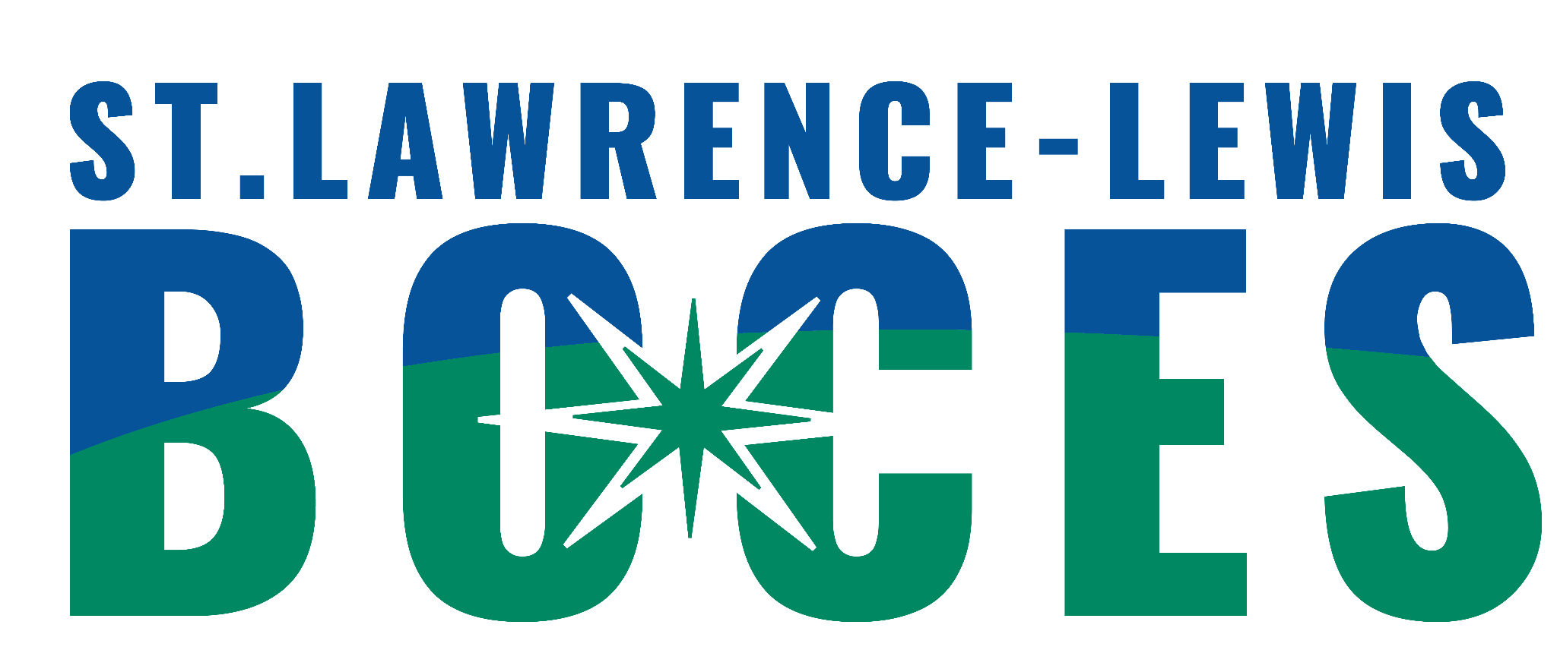
St. Lawrence-Lewis BOCES
6:1:2 Programs
Ogdensburg Crossroads
Referral Form

Date of Referral: __________________________________

Student’sName:________________________________DOB:__________Age:__________

Parent/Guardian(s):__________________________________________________________

Address:___________________________________________________________________

Phone/Contact Number:_______________________________

Home District:____________________________Classification:________________________

Other Agencies involved with student (If known, please include name of contact person):

Mental Health Service Provider:___________________________________________

MIT (Medical Intervention Team) _________________________________________

Outside Service Provider:_______________________________________

Dept. of Social Services:_________________________________________________

Probation:_____________________________________________________________

Other:________________________________________________________________

EDUCATIONAL PROFILE

Most recent class placement (include names of teacher and counselor):

Please describe the precipitating events leading to referral (i.e. specific behavioral, social, and emotional difficulties, and most current discipline referrals):

Has a Functional Behavioral Assessment (FBA) and Behavior Intervention Plan (BIP) been completed? Date of last FBA ________________________

Criteria for return to school placement (including specific behavioral goals):

What is your tentative, future educational placement for this student?

Please attach the following paperwork to this form and send to:
1. Current IEP
2. Psychological Evaluation
3. List of current medications (at home and at school)
4. FBA and BIP/ Discipline Referrals
5. Related Service Evaluations
6. Progress Reports
7. Contacts with External Agencies
8. SPOA Referral Completed

If sending by email, which is preferred, please send copies to the following:
reginald.mcdonald@sllboces.org
kady.sharp@sllboces.org (Grades K - 6)
dillon.chichester@sllboces.org Crossroads Referrals (Grade 7 - 10)

If sending by mail, send completed referral to:
St. Lawrence-Lewis BOCES
P.O. Box 231
Canton, NY 13617
Attn: Crystal LaPoing

The 6:1:2 team will review the referral to determine placement based on information provided and similarity of need. Once the referral has been reviewed, the CSE chair will be notified. It is highly recommended that parents/ guardian and student visit the program prior to the final placement decision.

