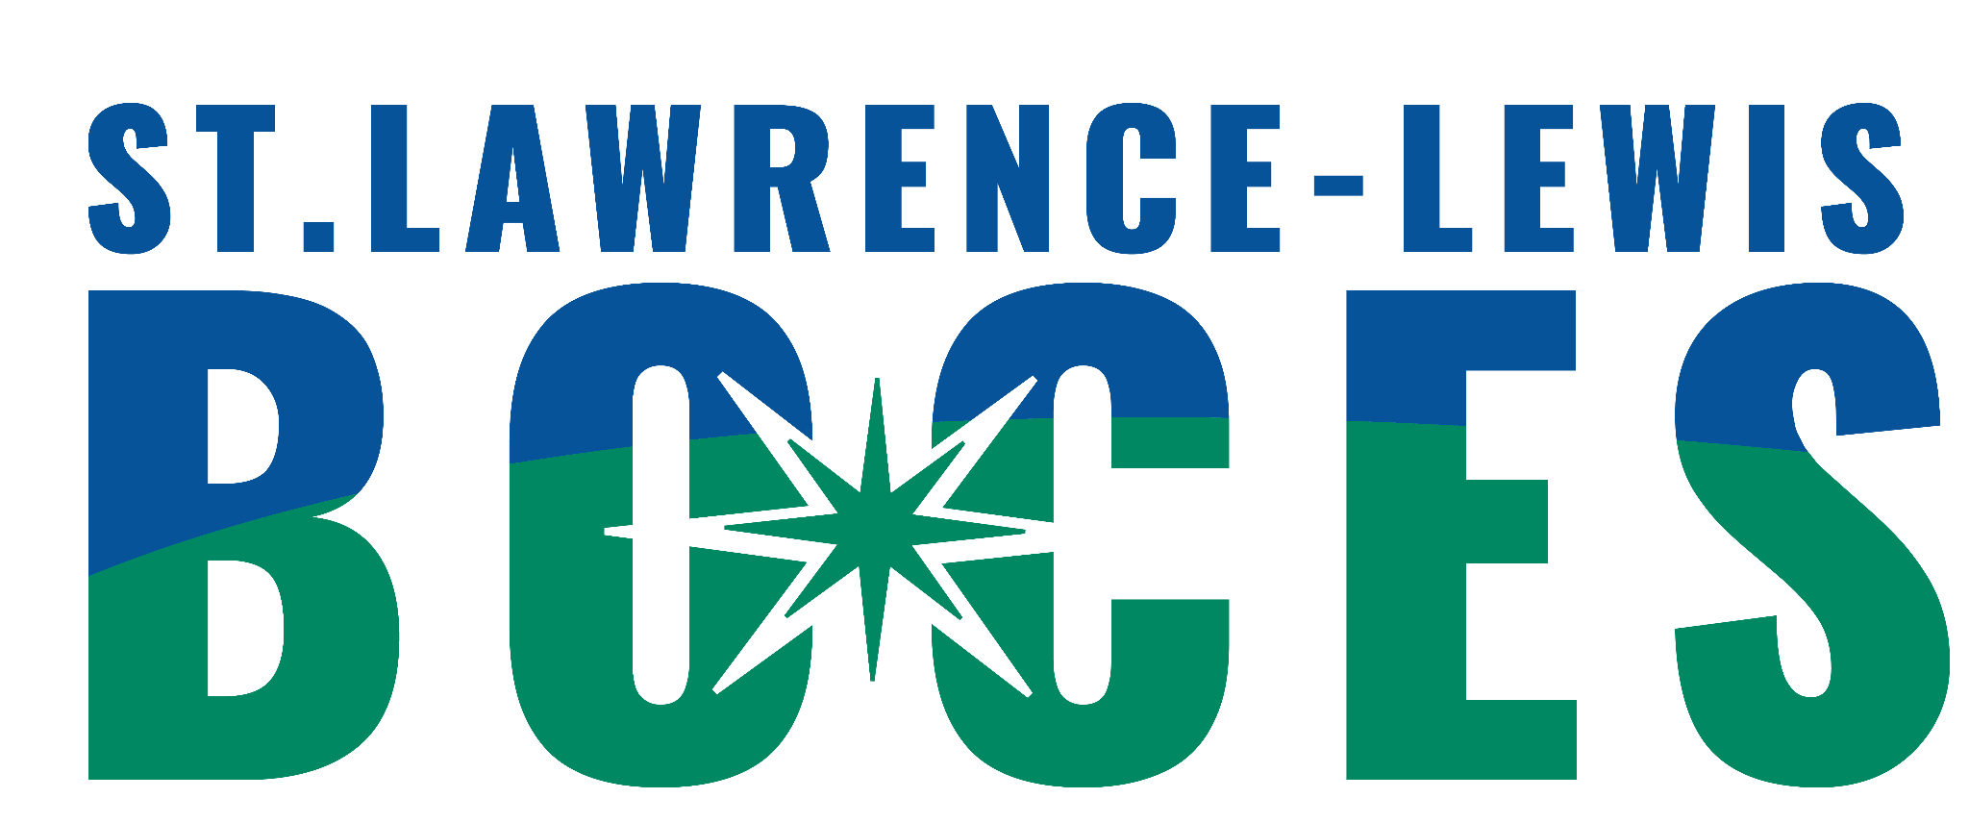
St. Lawrence-Lewis BOCES
8:1:1 Programs
Heuvelton, Ogdensburg, Potsdam

Date of Referral: __________________________________

Student’sName:________________________________DOB:__________Age:__________

Parent/Guardian(s):__________________________________________________________

Address:___________________________________________________________________

Phone/Contact Number:_______________________________

Home District:____________________________Classification:________________________

Other Agencies involved with student (If known, please include name of contact person):

Mental Health Service Provider:___________________________________________

MIT (Medical Intervention Team) _________________________________________

Outside Service Provider:_______________________________________

Dept. of Social Services:_________________________________________________

Probation:_____________________________________________________________

Other:________________________________________________________________

EDUCATIONAL PROFILE

Most recent class placement (include names of teacher and counselor):

Please describe the precipitating events leading to referral (i.e. specific behavioral, social, and emotional difficulties, and most current discipline referrals):

Has a Functional Behavioral Assessment (FBA) and Behavior Intervention Plan (BIP) been completed? Date of last FBA ________________________

What is your tentative, future educational placement for this student?

Please attach the following paperwork to this form and send to:
1. Current IEP
2. Psychological Evaluation
3. List of current medications (at home and at school)
4. FBA and BIP/ Discipline Referrals
5. Related Service Evaluations
6. Progress Reports
7. Contacts with External Agencies

If sending by email, which is preferred, please send copies to the following:
reginald.mcdonalda@sllboces.org
kady.sharp@sllboces.org for Potsdam Central School
julie.austinkormanyos@sllboces.org Kennedy School Ogdensburg
lori.murray@sllboces.org Heuvelton Central School

If sending by mail, send completed referral to:
St. Lawrence-Lewis BOCES
P.O. Box 231
Canton, NY 13617
Attn: Crystal LaPoint

The 8:1:1 team will review the referral to determine placement based on information provided and similarity of need once all information necessary is received according to the BOCES Intake Guidelines.

