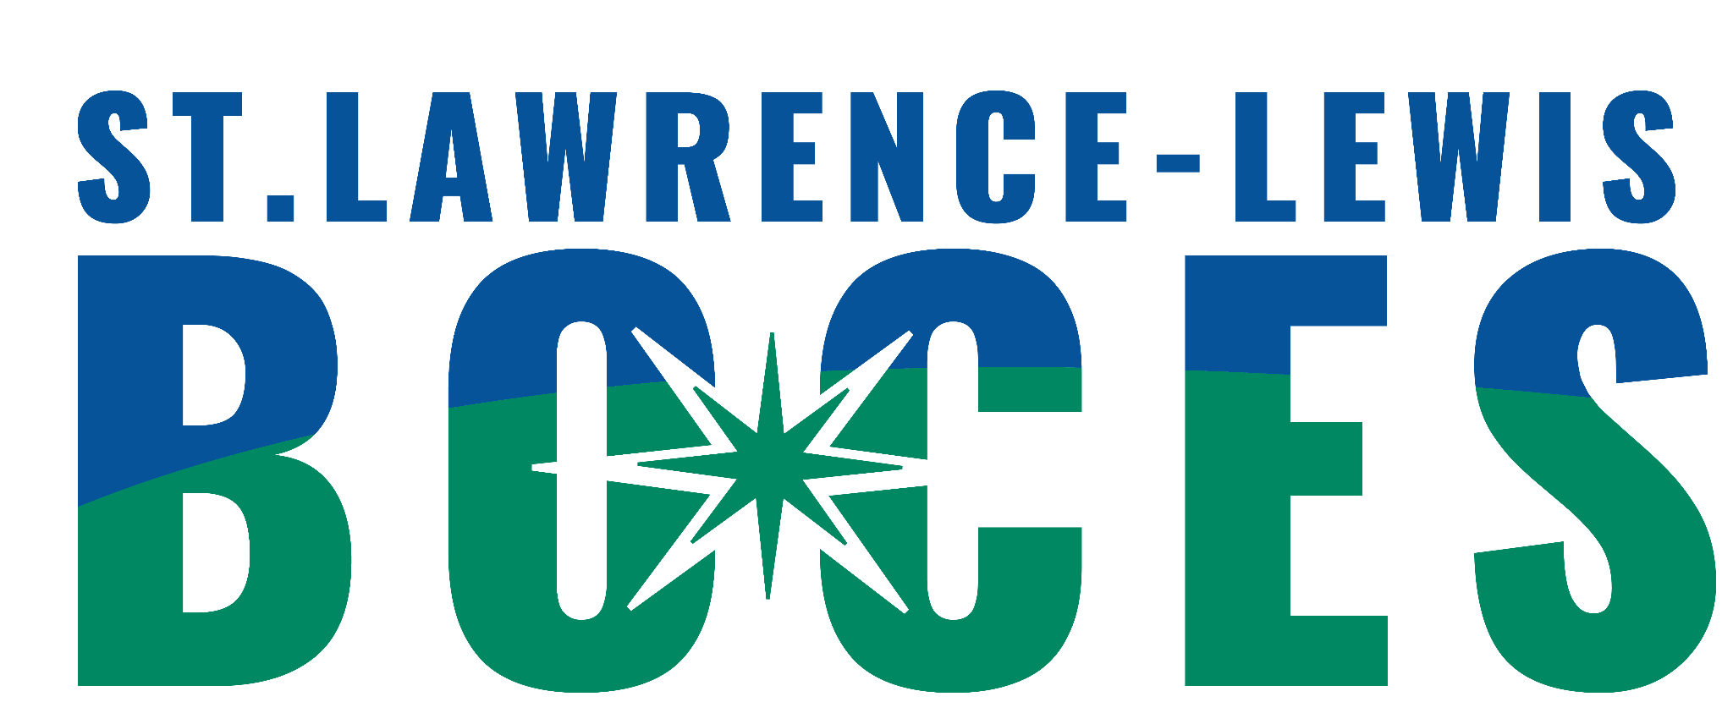

St. Lawrence-Lewis BOCES
Community Connections Program

Ogdensburg and Norwood-make copy

Date: ______________

6:1:1 ◻Norwood or ◻Ogdensburg (send to Lori Murray)

Student’s Name: _____________________ District: ______________________
District
Date of Birth: _______________________ Contact Person: ________________

Address: _________________________________

_____________________________ Parent’s Phone Number: _________

Parent/Guardian: ___________________________________________________

Background Data Outside Agencies
(list those applicable)

Classification: _____________________ Probation Worker: ______________

I. Q. Verbal: ______________________ Case/Social Worker: ____________

Full Scale: ________________________ Mental Health: _________________
YAP:_________________________

Current Math: ______ Reading: ______ Other: ________________________

Number of credits, if any: ___________ Medical

Current Program: __________________ Medications: __________________
CTE:_______________________
BOCES CLASS:_____________________

Home Instruction in past year? _______ Physician: ____________________

# of suspensions in past year? ________ Physical Condition: _____________

# of days absent in past year? ________

ALTERNATIVE SPECIAL EDUCATION REFERRAL
(continued)

Reason for Referral: _________________________________________________

_________________________________________________________________

_________________________________________________________________

Expectation for student: ______________________________________________

_________________________________________________________________

_________________________________________________________________

_________________________________________________________________

Is there anything that the team should know prior to the screening?

________________________________________________________________

Paperwork to be sent with Referral to:

Lori Murray lori.murray@sllboces.org

*Please send the following necessary information along with your referral.

______ Current IEP
______ Most recent Psychological
______ Most recent Educational Testing
______ Functional Behavioral Analysis/Behavior Intervention Plan
______ Progress Notes/Report Card or Junior/Senior High Transcript (Current and Previous School Year)
______ Incident reports (current and previous year – for 2 years)
______ A list of any criminal arrests, convictions, or current charges with supporting paperwork accessible.

